**#There are two ways to find out covid Impact on Life expectancy**

#1) The **number of extra deaths in the country from start of pandemic to end of pandemic:**

In this way Total death in country because of pandemic, and total death without Covid pandemic is measured and compare it with total detection rate for Population

#2) **COVID-19 prevalence threshold:**

In this way we calculate the total COVID prevalence rate in country and make a direct relation of it to Life expectancy.

**Gaining from the Examples of US and Maharashtra**

**#Study Period : - 31 dec 2019 to 20 december 2020**

COVID-19 has infected more than 1.8 million people, of whom 48,746 had died in Maharashtra until 20th December 2020. COVID-19 attributable deaths amount to 5.3% of the total deaths. These additional deaths could have been prevented in the absence of COVID-19. The case-fatality ratio in the state is 2.57, higher than the national average of 1.5. The rate of infection in Maharashtra (15 infected per 1000 people) is more than double compared to the national average (7 infected per 1000 people). In 2018 (the pre-COVID-19 period), the life expectancy at birth was 73.2 years in the state compared to 69.7 years in India as a whole.

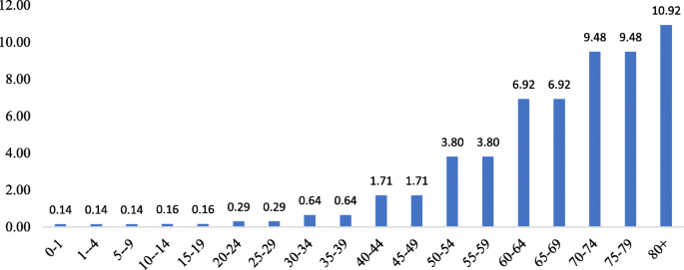

Age-specific case fatality ratio in Maharashtra, India 2020

Figure [1](https://bmcinfectdis.biomedcentral.com/articles/10.1186/s12879-021-06026-6#Fig1) estimates the age-specific case fatality ratio in the state. The ASCFR shows an increasing pattern with age. It is as low as 0.14 in the age group 10-year and reaches 7% by age 60 and 11% in the age group 80 years and above.

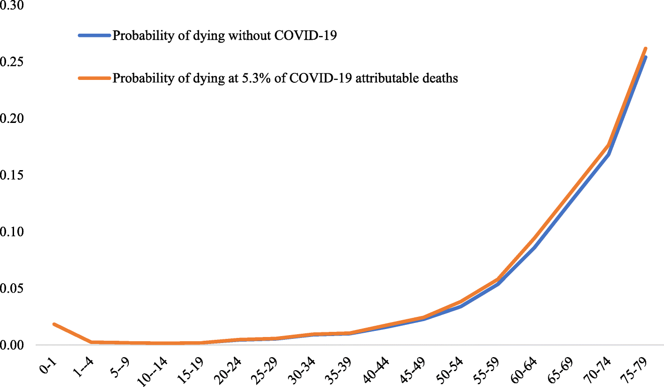

Figure [2](https://bmcinfectdis.biomedcentral.com/articles/10.1186/s12879-021-06026-6#Fig2) compares the life table probability of deaths with and without the COVID-19 infection in Maharashtra.

Life table probability of death without and with 5.3% COVID-19 attributable deaths in Maharashtra, India 2020

#3) Calculation of Covid weights respect to Life expectancy calculations.

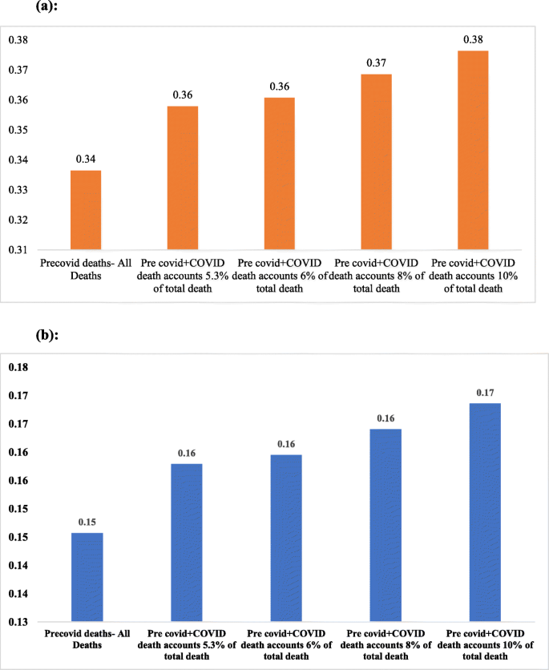

Figure (a) Explains:

The premature mortality pre-COVID-19 was 0.34 but increased to 0.36 with COVID-19. Given the current mortality pattern, if the share of deaths attributable to the infection reaches 8 and 10%, the premature mortality would increase to 0.37 and 0.38, respectively.

#Fig (B) explain:

In the working-age group 20-45 the probability of death due to the current rate of infection has increased to 0.16 from 0.15 in the pre-COVID-19 period. Under the assumed 10% COVID-19 attributable death share scenario, the probability of death in the working-age group would increase to 0.17.

Figure [4](https://bmcinfectdis.biomedcentral.com/articles/10.1186/s12879-021-06026-6#Fig4) Explains:

shows the reduction in life expectancy at birth in various scenarios of COVID-19 attributable deaths in Maharashtra. Estimates suggest that the ongoing COVID-19 pandemic has significantly affected the life expectancy in the state. Life expectancy has already shrunk by 0.8 years due to the current level of COVID-19 attributable deaths. *in the scenario that COVID-19 attributable deaths would amount to 6, 8, and 10% of total deaths in the state, the life expectancy at birth would reduce by 0.9, 1.1, and 1.4 years respectively.*

**Fig. 4**

[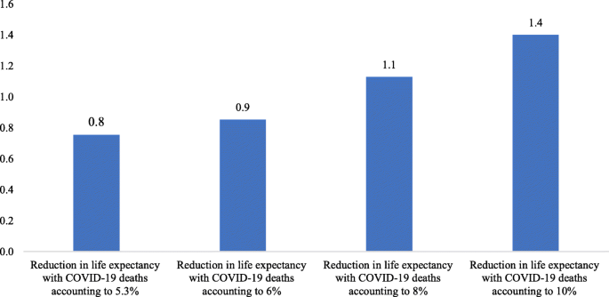](https://bmcinfectdis.biomedcentral.com/articles/10.1186/s12879-021-06026-6/figures/4)

Reduction in life expectancy at birth (in years) due to COVID-19 attributable deaths in Maharashtra, India 2020

For COVID 19 WAVE 2nd India

Similarly, the number of maternal deaths is also expected to increase in 2021 as a result of the pandemic, with the highest number of deaths anticipated in India (7,750, 18% increase)

#so as per the study if Death rate is 10 % life expectancy is reduced by 1.4 years from Birth

#but as per reports Death rate after Covid 19 is goes upto 18 % so life expectancy should be lower by 2.5-2.8 years in india

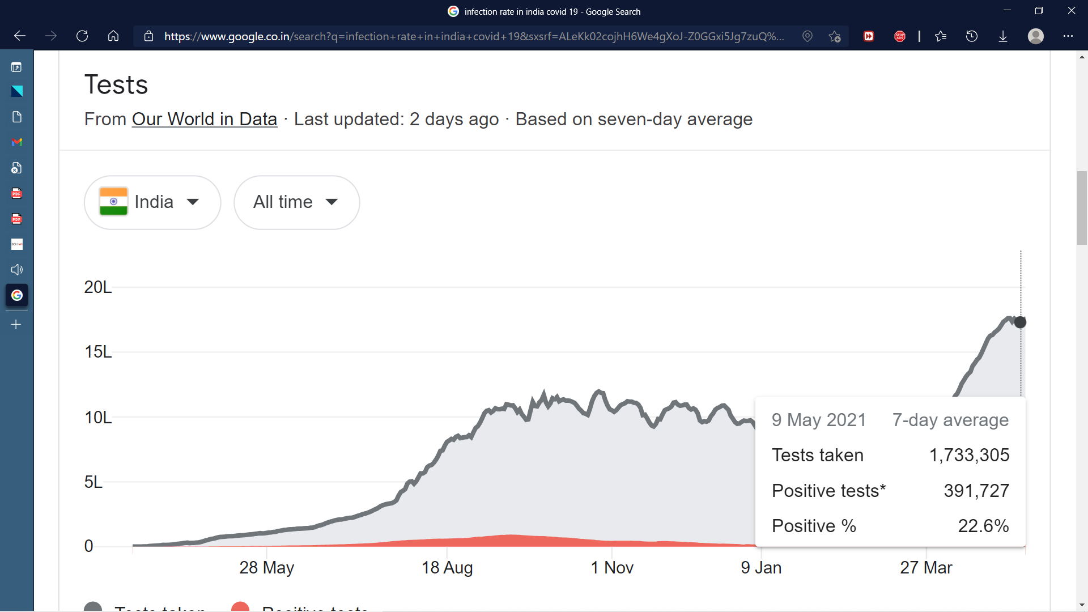

But according to the graph from world in data

Detection rate of india is Goes upto 22.6%

But This all studies are applied for the First wave of COVID 19

Refrences

[COVID-19 Disruptions: India Projected To Register Surge in Child, Maternal Deaths - The Wire Science](https://science.thewire.in/health/covid-19-disruptions-india-could-register-surge-in-child-maternal-deaths/)

[Impact of COVID-19 infection on life expectancy, premature mortality, and DALY in Maharashtra, India | BMC Infectious Diseases | Full Text (biomedcentral.com)](https://bmcinfectdis.biomedcentral.com/articles/10.1186/s12879-021-06026-6#Sec6)

[India Infant Mortality Rate 1950-2021 | MacroTrends](https://www.macrotrends.net/countries/IND/india/infant-mortality-rate)

[Assessing the potential impact of COVID-19 on life expectancy (plos.org)](https://journals.plos.org/plosone/article?id=10.1371/journal.pone.0238678)

